**Experiment No: 12**

**Title:** Cloud Computing and Infrastructure mini-project Google Cloud S3 bucket and load balancer

**Aim:** To deploy an Reactjs application on google cloud

**Case Study:**

**What Is Google Cloud?**

Google Cloud is a cloud computing platform and suite of services offered by Google, one of the world's leading technology companies. Google Cloud provides a wide range of infrastructure, computing, storage, machine learning, data analytics, and other cloud-based services to businesses, developers, and individuals. These services can be used for a variety of purposes, including building and deploying web applications, hosting websites, running data analytics, managing databases, and more.

Some of the core services and products offered by Google Cloud include:

1. Compute Engine: This service allows you to create and manage virtual machines (VMs) in the cloud. It's suitable for hosting applications and workloads.

2. App Engine: A Platform as a Service (PaaS) that simplifies the process of building and deploying web applications.

3. Kubernetes Engine: A managed Kubernetes service for container orchestration and management.

4. Cloud Storage: Provides scalable and durable object storage for your data and files.

5. BigQuery: A fully managed, serverless data warehouse for running fast and SQL-like queries on large datasets.

6. Cloud Machine Learning Engine: A platform for building and deploying machine learning models and AI applications.

7. Cloud Datastore: A NoSQL database service for storing and retrieving data for web and mobile applications.

8. Cloud SQL: A managed database service for popular relational databases like MySQL, PostgreSQL, and SQL Server.

9. Cloud Spanner: A globally distributed and horizontally scalable database service that combines the benefits of both relational and NoSQL databases.

10. Cloud Pub/Sub: A messaging service for building event-driven systems and applications.

11. Cloud Functions: A serverless compute service that allows you to run event-triggered functions in response to various cloud events.

12. Identity and Access Management (IAM): A service for managing user and application access to resources in the Google Cloud platform.

13. Networking: Google Cloud offers a range of networking services, including Virtual Private Cloud (VPC), Load Balancing, and Cloud CDN, for building secure and scalable network architectures.

Google Cloud competes with other major cloud providers such as Amazon Web Services (AWS) and Microsoft Azure. It is used by businesses of all sizes to leverage the power of cloud computing to run applications, store data, and access a wide range of services without the need for significant on-premises infrastructure.

Google Cloud Load Balancer is a service provided by Google Cloud Platform (GCP) that helps distribute incoming network traffic across multiple virtual machine (VM) instances or other resources to ensure high availability and scalability for your applications. Load balancing is crucial for handling web traffic, application requests, and other network services efficiently and reliably.

**Google Cloud offers several types of load balancers:**

1. **HTTP(S) Load Balancing:** This is a global, fully-distributed load balancer designed for distributing HTTP and HTTPS traffic. It provides content-based routing, SSL termination, and global anycast IP addresses. It is ideal for serving web applications and content to users worldwide.

2. **TCP/UDP Load Balancing:** This type of load balancer is used for distributing non-HTTP traffic, such as gaming or other network services that require TCP or UDP. It can balance traffic across instances within a single region or globally.

3. **Network Load Balancing:** This is a regional load balancer that distributes TCP/UDP traffic across VM instances within a single region. It's suitable for high-performance and low-latency applications.

4. **Internal TCP/UDP Load Balancing:** This load balancer is used for distributing traffic to backend services within your Virtual Private Cloud (VPC) network. It's meant for internal applications or services.

Google Cloud Load Balancers offer features like health checking, auto-scaling, and intelligent routing, ensuring that traffic is routed to healthy backend instances, and scaling resources up or down based on demand. They also provide DDoS protection and can be easily configured and managed through the Google Cloud Console or using the Google Cloud SDK.

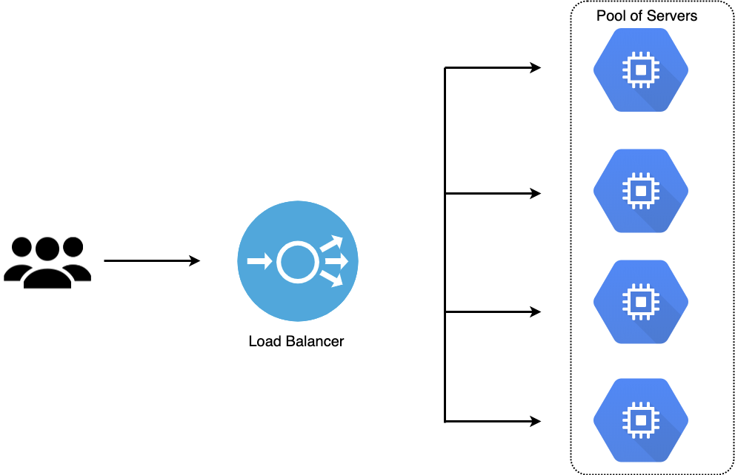

**S3 Bucket**

Google Cloud Storage is Google's equivalent of Amazon S3 (Simple Storage Service), which is a scalable object storage service. Google Cloud Storage allows you to store and retrieve data in the cloud in the form of objects. While it is not an "S3 bucket," the concept and functionality are similar. Here's how Google Cloud Storage works and how it's analogous to S3 buckets:

1. Buckets: In Google Cloud Storage, you create containers called "buckets" to organize and store your objects. Think of buckets as similar to S3 buckets. Buckets have a globally unique name and can be used to group related objects.

2. Objects: Objects are the individual data items you store within buckets. These could be files, images, videos, documents, or any other type of data. Objects in Google Cloud Storage are similar to objects in S3.

3. Access Control: You can control access to your Google Cloud Storage buckets and objects using Identity and Access Management (IAM) policies. This allows you to manage who can read, write, or delete data.

4. Storage Classes: Google Cloud Storage offers various storage classes that provide different performance and pricing options, including Standard, Nearline, Coldline, and Archive storage classes, similar to S3's storage classes.

5. Data Transfer and Management: Google Cloud Storage offers features for data transfer, data lifecycle management, versioning, and more, which are similar to the capabilities provided by Amazon S3.

6. Integration: Google Cloud Storage is tightly integrated with other Google Cloud services, making it easy to use for building cloud-native applications, data analytics, and more.

Google Cloud Storage, like Amazon S3, is highly reliable, durable, and scalable, making it suitable for a wide range of use cases, such as data backups, content delivery, media storage, and big data analytics. The key difference is that Google Cloud Storage is part of the Google Cloud Platform ecosystem, while S3 is part of Amazon Web Services (AWS). The choice between the two largely depends on your specific cloud provider preferences and requirements.

**Implementation:-**

**Cloud CDN:-**

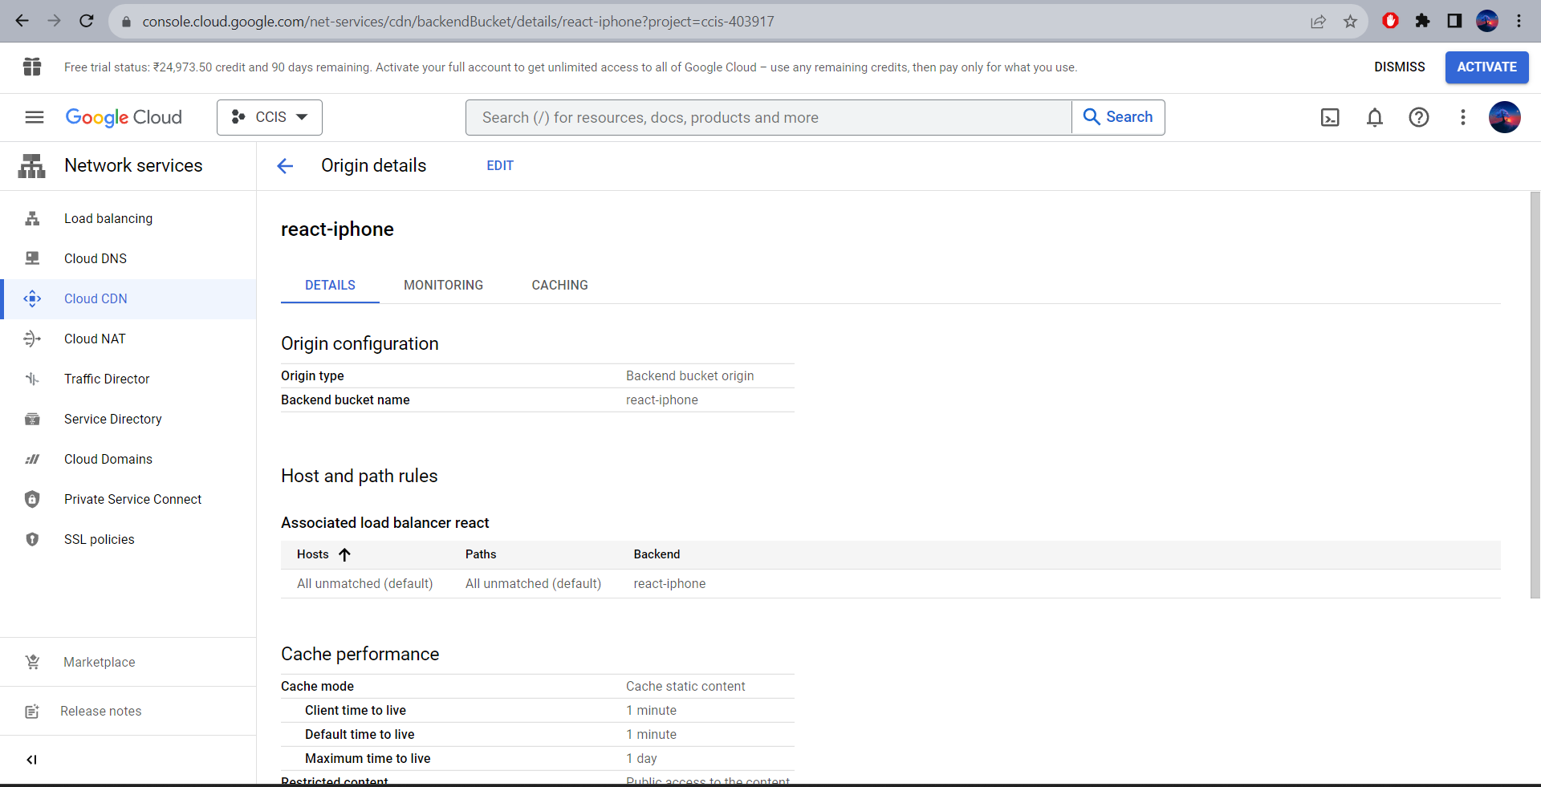

**Load Balancer:-**

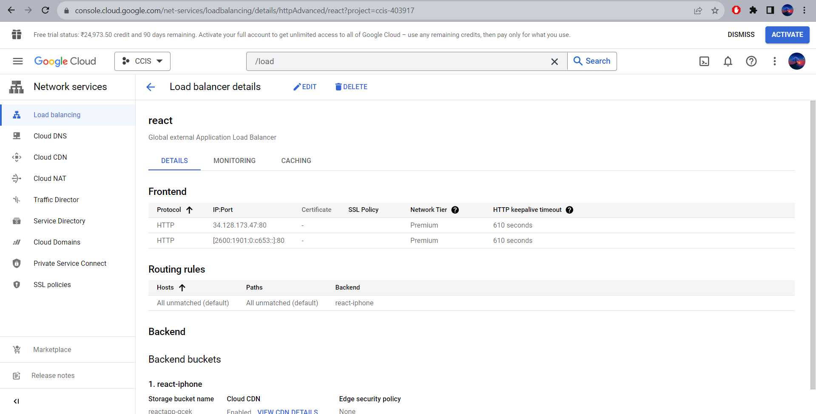

**Deployment:-**

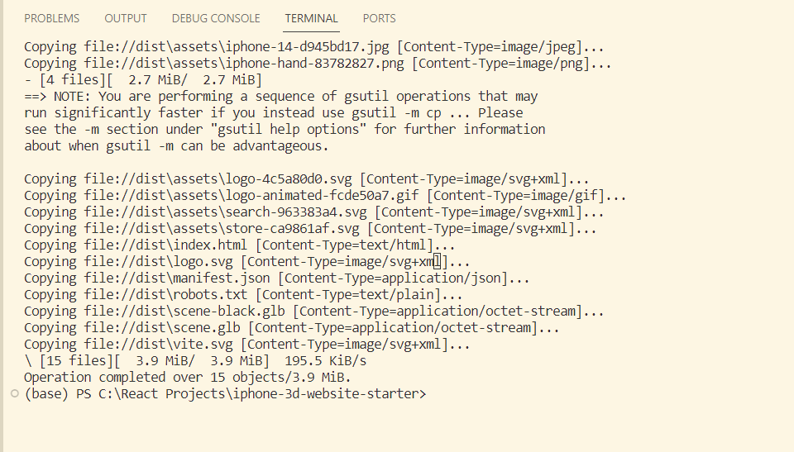

**Website :-**

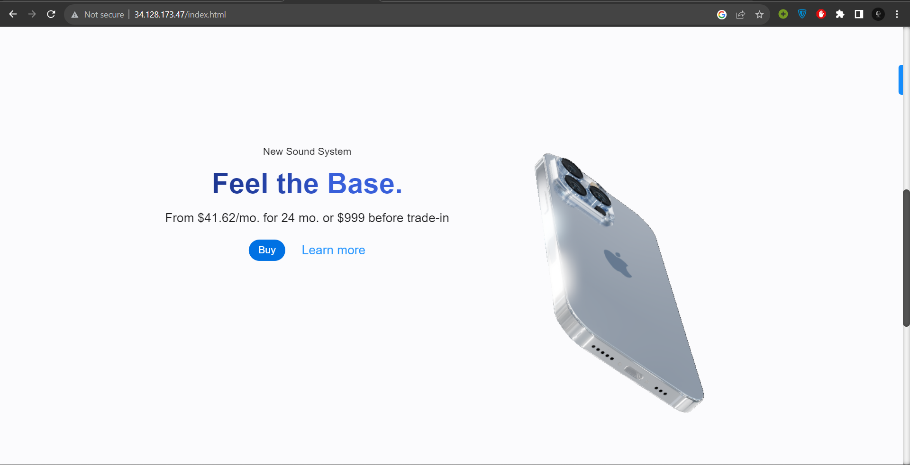

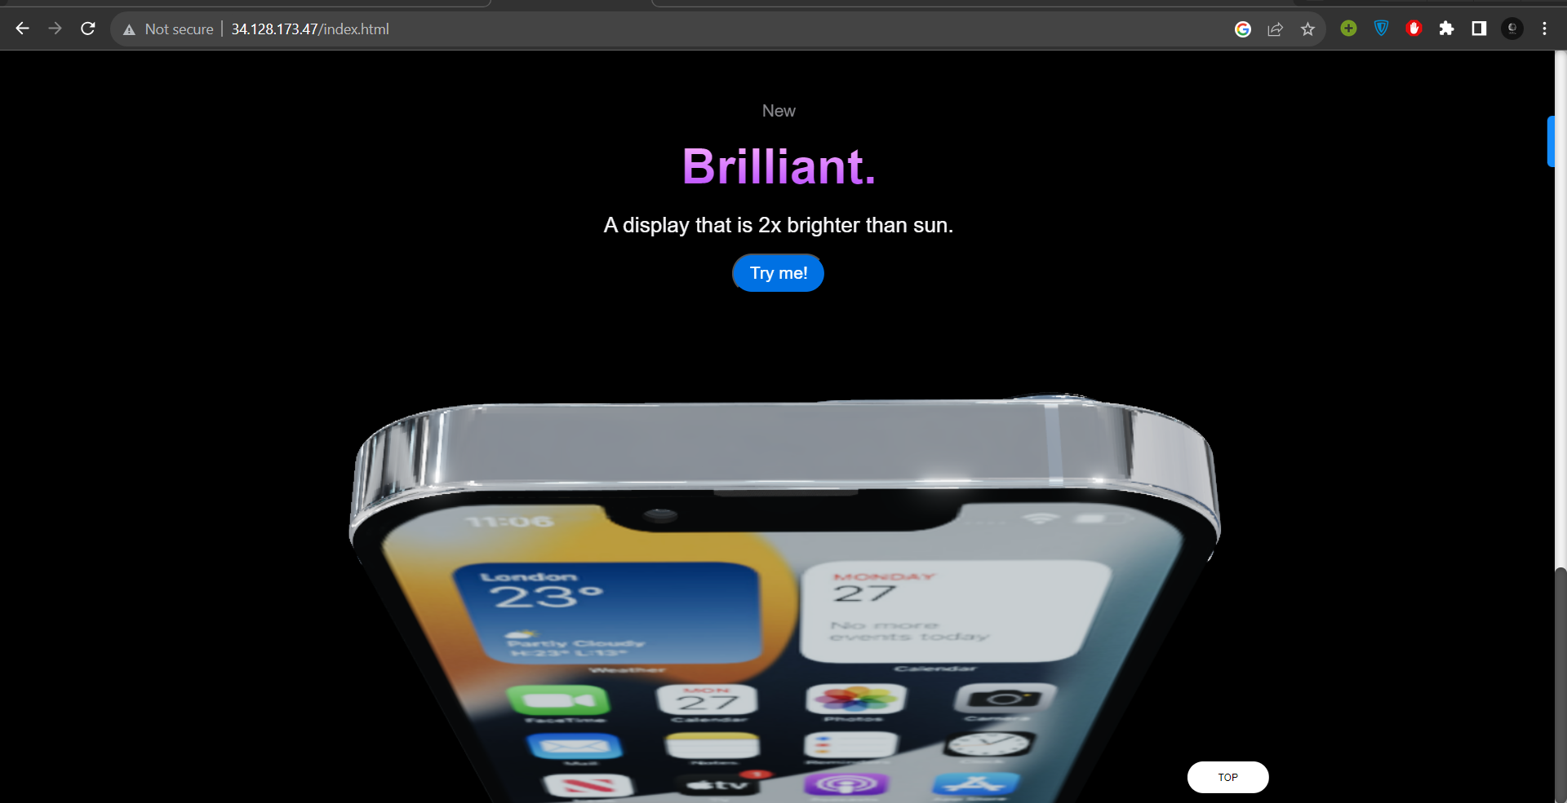

**Conclusion:**

Thus, I have created a mini project using google cloud s3 bucket, load balancer and reactjs